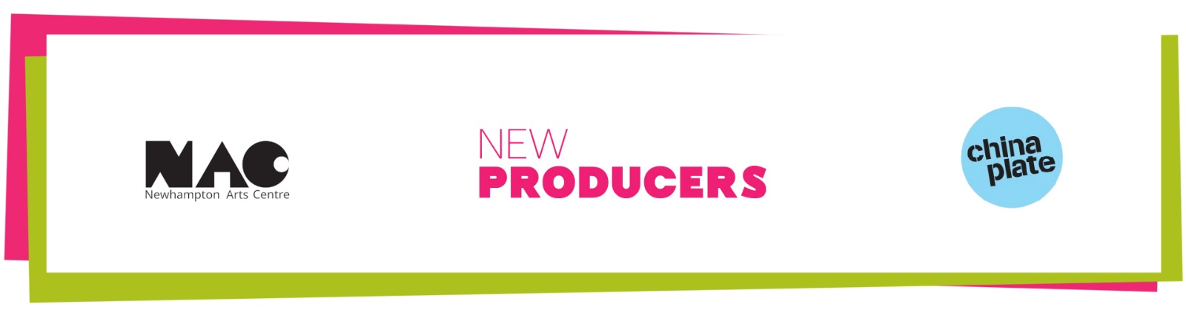

Equal Opportunities Information

Newhampton Arts Centre & China Plate are equal opportunities employers and aim to be organisations that embrace equality of opportunity. In line with established good practice and to enable us to monitor the diversity of our applicants, we would request that you complete and submit this form. All of the information provided will be treated as confidential and anonymous and if part of a recruitment process, will be kept separate from each application. We fully appreciate that some of the questions cover sensitive and personal information. If you do not want to answer these questions, we would like to encourage you to state 'Prefer Not To Say' rather than ignore the form completely. Thank you for taking the time to complete this form.

Do you consider yourself Male/Female/Prefer not to say
Do you consider yourself disabled/non-disabled/prefer not to say
How would you describe your ethnic background?

